Mandatory

# Exercise 1

|  |
| --- |
| **function** Expectiminimax-Decision(*state*) **returns** *an action*  *a’* ← Nil  *v’* ← -∞  **for each** *a* **in** Actions(*state*) **do**  *v* ← Change-Value(Result(*state*, *a*), Min)  **if** *v* > *v’* **then**  *v’* ← *v*  *a’* ← *a*  **return** *a* |
| **function** Change-Value(*state*, *nextPlayer*) **returns** *a utility value*  *v* ← 0  **if** *nextPlayer* **is** Max **then**  **for each** *a* **in** Actions(*state*) **do**  *v* ← Sum(*v*, P(*a*) * Max-Value(Result(*state*, *a*))  **else**  **for each** *a* **in** Actions(*state*) **do**  *v* ← Sum(v, P(*a*) * Min-Value(Result(*state*, *a*))  **return** *v* |
| **function** Max-Value(*state*) **returns** *a utility value*  **if** Terminal-Test(*state*) **then return** Utility(*state*)  *v* ← -∞  **for each** *a* **in** Actions(*state*) **do**  *v* ← Max(*v*, Change-Value(Result(*state*, *a*), Min))  **return** *v* |
| **function** Min-Value(*state*) **returns** *a* *utility* *value*  **if** Terminal-Test(*state*) **then** **return** Utility(*state*)  *v* ← ∞  **for** **each** *a* **in** Actions(*state*) **do**  *v* ← Min(*v*, Change-Value(Result(*state*, *a*), Max))  **return** *v* |

# Exercise 2

## a)

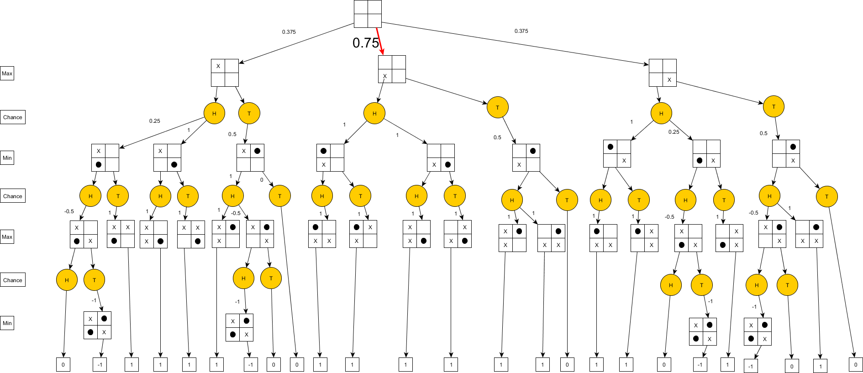

## b)

The best action given a head coin flip is for Max to place his piece in the bottom left corner, which has an expectiminimax value of 0.75.